Project Development
Phase Model Performance
Test

Date | 20 February 2026
Team ID | LTVIP2026TMIDS43288
Project Name | Online Payments Fraud Detection Using Machine Learning
Maximum Marks | 10 Marks

Model Performance Testing:
Project team shall fill the following information in model performance testing template.

S.No | Parameter | Values | Screenshot
1. | Model Summary | Total number of data =  3286 | 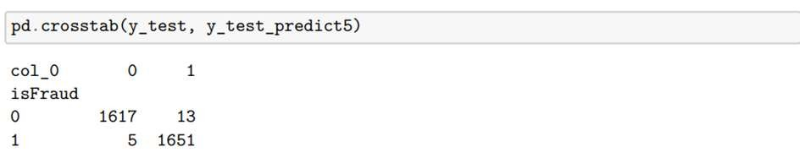  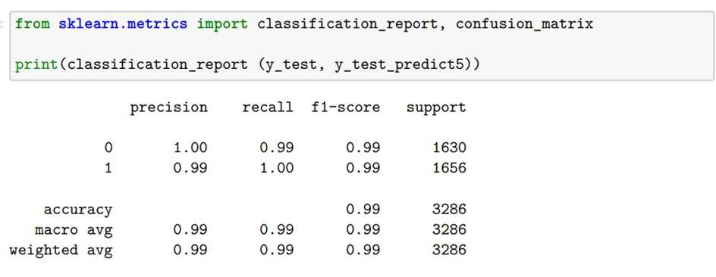
2. | Accuracy | Training accuracy –  86.22%  Testing accuracy –  99.45% | 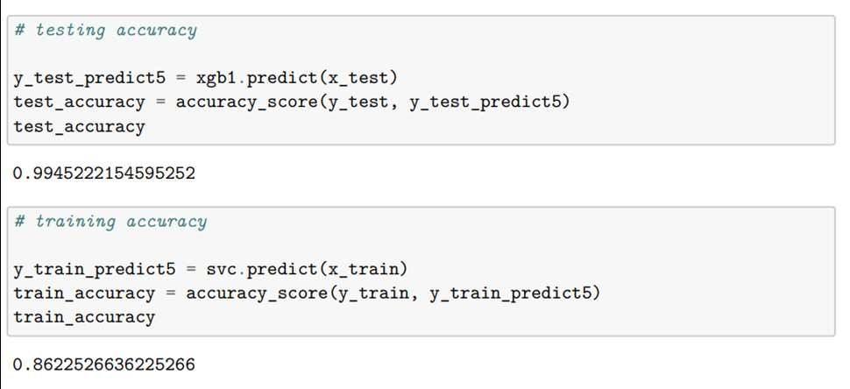
3. | Confidence Score  (Only Yolo  Projects) | Class Detected - NA  Confidence Score - NA | Not Applicable

Screenshot:

Model Summary –

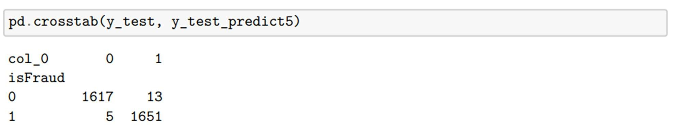

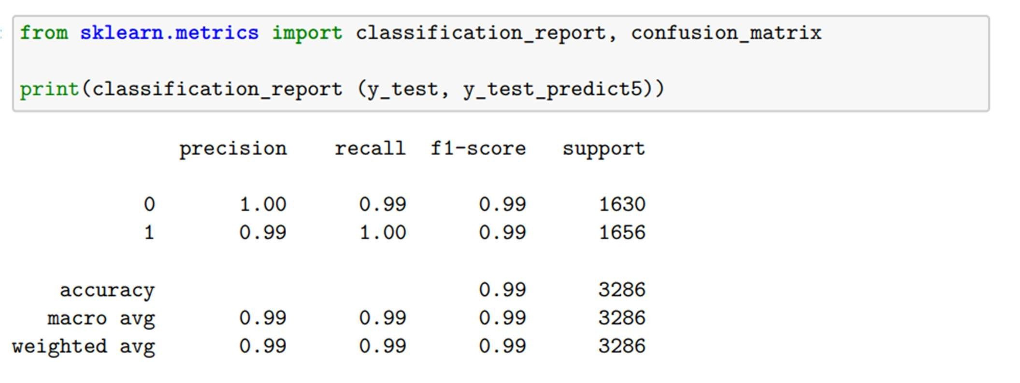

Accuracy -

